**CSC 355 Database Systems**

**Fall Quarter 2018**

**Assignment 1**

**Terry Yu**

**Part 1. SQL Developer Connection (20 points)**

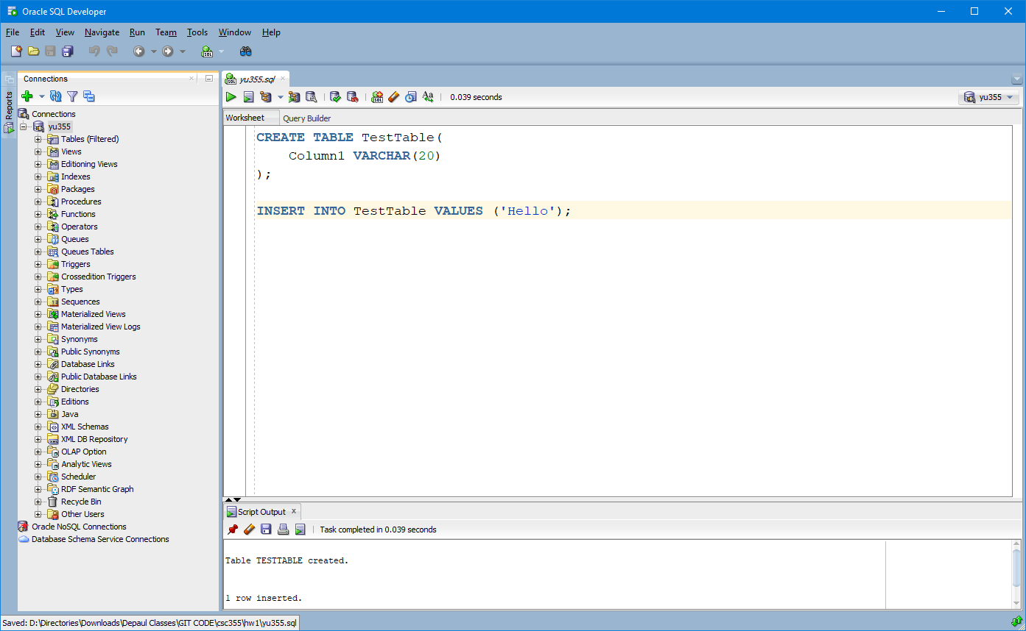

**Part 2. Relational Model (32 points)**

A. List the primary keys for each table.

ITEM: I_ID

PURCHASE: P_CustID, P_ItemID, P_Date

CUSTOMER: C_ID

B. List the foreign keys for each table.

ITEM: None

PURCHASE: P_CustID, P_ItemID

CUSTOMER: None

C. For each table, construct a tuple that does not violate any constraints.

ITEM VALUES (6, “Computer”, 32);

PURCHASE VALUES (3, 3, 1/21/2017);

CUSTOMER VALUES (4, “Dr. Robotnik”, “Miami”);

D. Which records can be removed from ITEM without violating any constraints?

#2 Jet Pack.

**Part 3. SQL DDL (48 points)**

**A.**

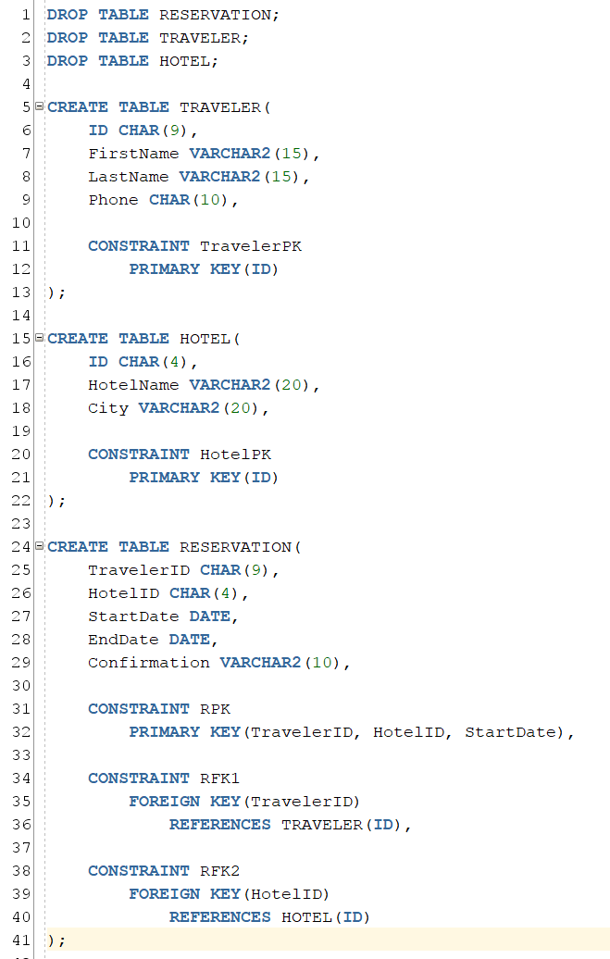

**A cont.**

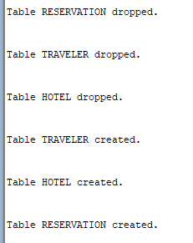

**B.**

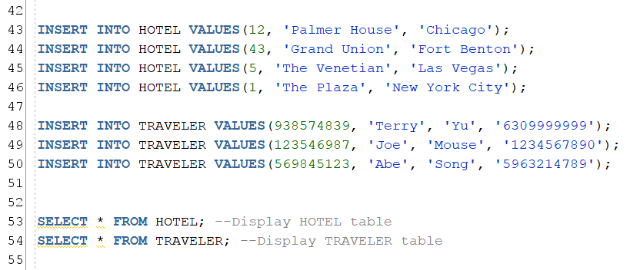

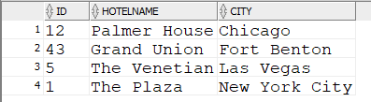

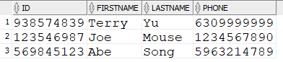

**C.**

